PGR HUB GUIDANCE AND TERMS AND CONDITIONS FOR ROOM BOOKINGS 2026–27

PGR Hub, Level Two, Senate House, University of Bristol, Tyndall Avenue, Bristol, BS8 1TH.
This guidance applies to the following bookable spaces in the PGR Hub:
- Collaborative Space - the study desks, seated lounge, and standing food area combined (approx. capacity of 80)
- Training Room - Room 2.22 (approx. capacity of 40, minimum no. of users 8)
- Breakout Space - Room 2.21 (approx. capacity of 8)

General Bookings Policy:
- All bookings must in some way relate to postgraduate research (PGR) student activities at the University.
- This can include study, meetings, training & workshops, and social or wellbeing events as well as staff-led training or events organised for an audience of PGRs.
- Ticketed events or those requiring registration must generally be free and open to all PGRs across the University, unless you are booking specifically for a Faculty/School/DTE cohort.
- The Bristol Doctoral College reserves the right to cancel or amend bookings if the below guidance is not followed or an event/activity is deemed inappropriate for the nature of the PGR Hub.
- Please add buffer times to your booking. Therefore, you have enough time to set up and clean up the training room after your session.
- Please let the PGR Hub staff know via uob-pgr-hub@bristol.ac.uk as soon as possible if the booking is no longer necessary.

Access:
- All PGRs and all UoB staff should have UCard access to the PGR Hub. If your card does not let you access the PGR Hub, please contact the PGR Hub Assistant at uob-pgr-hub@bristol.ac.uk to have your UCard access enabled.
- If you have difficulties accessing the Hub outside of standard office hours, please call Card Services at 01173311190 (internal 11190).
- The PGR Hub is open 8 am to 9pm, Monday to Friday and the PGR Hub is also open on Saturdays and Sundays from 9 am to 6 pm but without BDC staff on site.

Staff:
- The Bristol Doctoral College office within the PGR Hub is generally staffed from 9 am to 5 pm, Monday to Friday. The PGR Hub assistant is generally in the office between 9 am – 2 pm on weekdays except Thursdays. However, we cannot guarantee that BDC staff will be present around the time of your event or be able to assist. Please make sure you plan time to set up and tidy up your event following these guidelines. If you need a demonstration of how anything works, this must be arranged in advance by contacting the PGR Hub mailbox uob-pgr-hub@bristol.ac.uk.
- Please contact Bristol Doctoral College doctoral-college@bristol.ac.uk for general PGR student enquiries and PPD trainings.
- Please contact Bristol Doctoral College engagement mailbox bdc-engagement@bristol.ac.uk with enquiries specific to events and activities at the PGR Hub.
- For enquiries relating to the PGR Hub and bookings, please get in touch with the PGR Hub mailbox uob-pgr-hub@bristol.ac.uk.

Health and Safety:
- Please refer to the risk assessment for standard activities in the PGR Hub. If your use of the space will involve additional risks not fully covered by this risk assessment, please contact uob-pgr-hub@bristol.ac.uk. Examples of additional risks include:
  - Equipment or substances not standard to the PGR Hub or households;
  - Physical activity with risks beyond basic moving and handling;
  - High profile or controversial events;
  - Fire safety risks exceeding normal levels.
- Estates Assistants are present in the building from 8 am to 10 pm. The building is cleared at 10 pm every day. Events must therefore end by 9 pm, to ensure adequate time for cleaning (please be aware that UCards do not work to enter the PGR Hub after 9 pm).
- Security Services operates a 24/7/365 operation:
  - In the event of EMERGENCY ONLY ring 0117 3311223 (internal 112233). If you require an ambulance, ring 999 first and then inform Security Services. All calls to this number will be recorded for security purposes.
  - For Non-Emergency security issues please call 0117 928 7848 (internal 87848). All calls to this number will be recorded for security purposes.
- In the event of fire, please evacuate from the nearest available exit: this is the main entrance of the building, or the fire exit in the Training Space (Room 2.22).
  - Please ensure that you exit the Hub immediately upon the sound of alarm, in an orderly fashion. Fire marshals will be present during standard office hours to direct you to the nearest exit. Outside office hours, Estates Assistants will ensure the building is clear.
  - The assembly point is outside across Tyndall Avenue, at Royal Fort Gardens.
- Staff in the PGR Hub will have details of the nearest First Aider. Estates Assistants are trained in First Aid and will have access to a first aid kit, if necessary.
- In the event of an emergency please ring 999.

Cleanliness:
- The space is to be left clean and tidy as you found it. All tables need to be wiped with provided anti-microbial wipes or spray and blue roll.
- All rubbish should be cleared away into the appropriate bins provided in the main PGR Hub.
- You may move the furniture into any configuration required, but please ensure the room is returned to its original configuration, as you found it.

Refreshments Policy:
- Food/drink may be permitted in the Training Room if that is appropriate for the booking. Alternatively, food, drink, and any catering should be brought to the PGR Hub in the standing area of the main Collaborative Space.
- Alcohol is permitted, providing that it is catered or brought in by the event organiser. Event participants are not permitted to bring their own alcohol in.
- The event organiser is responsible for ensuring that only a reasonable amount of alcohol is consumed.
- Please consider those who may not imbibe in alcohol, or who do not wish to attend functions at which alcohol may be present when arranging your refreshments provision.
- Please ensure that any foods with allergens are appropriately identified.

Training Room – Room 2.22

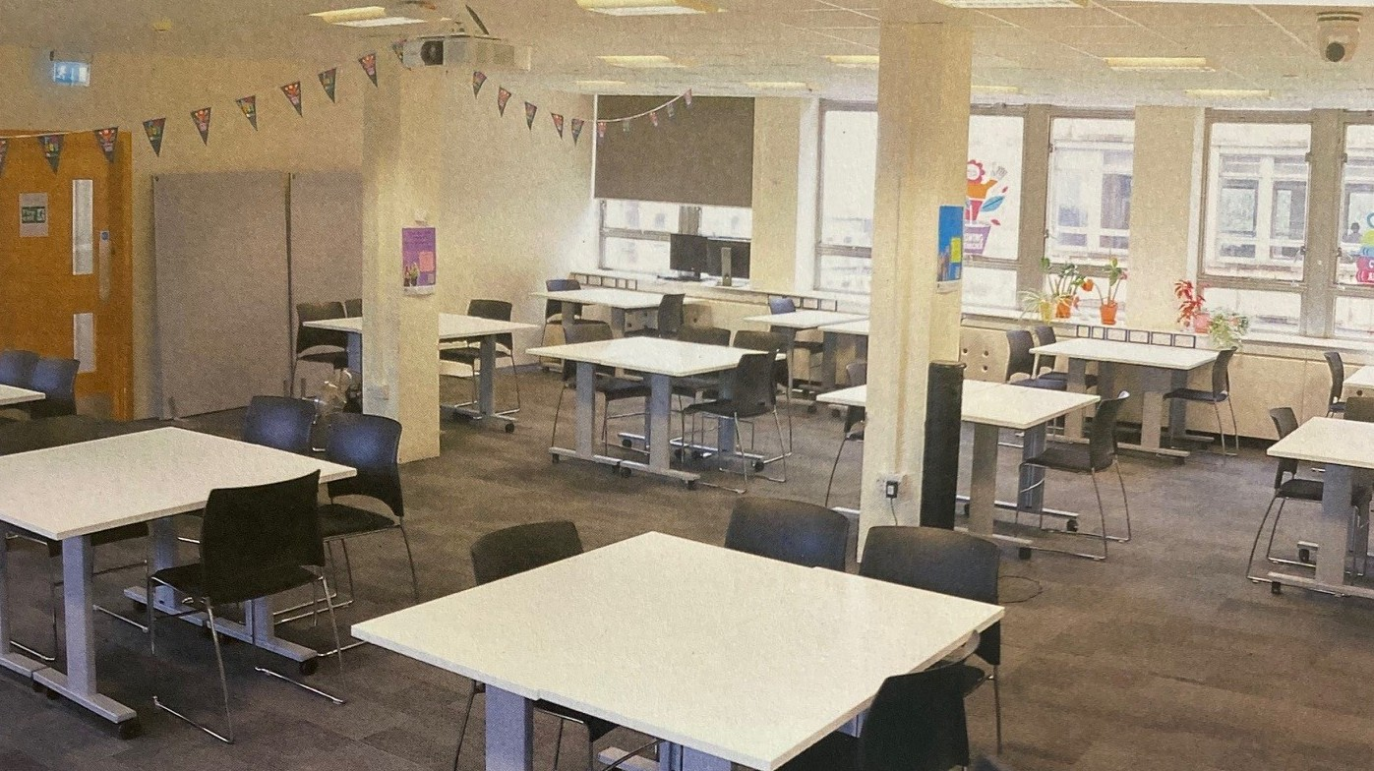
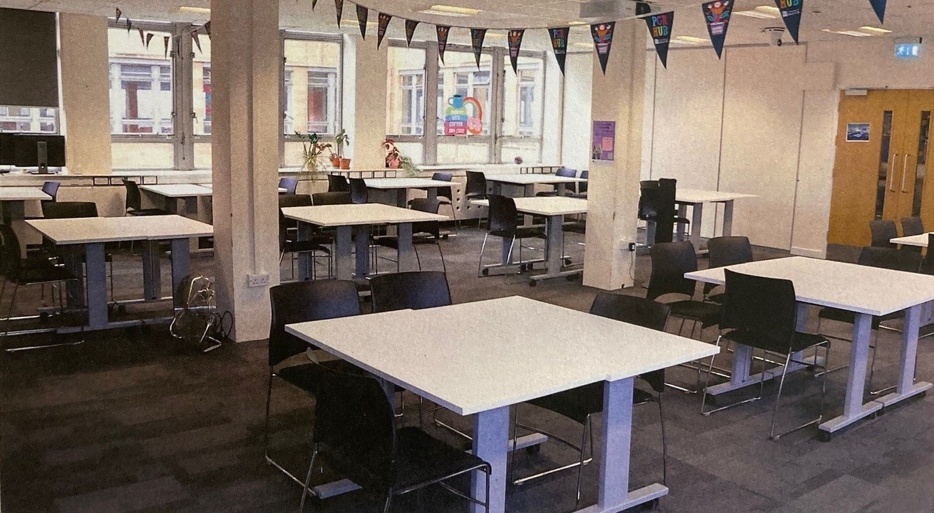

- There should be twelve or thirteen pairs of tables in total in the training room. Pairs of smaller tables should have 3 chairs around them. Pairs of larger tables should have 4 chairs around them, or 3 chairs if against a pillar or wall.
- Bookings are managed by BDC staff. To request to book the training room, please email uob-pgr-hub@bristol.ac.uk. PGRs can directly book 2.22 for sessions of up to 3 hours using Microsoft Bookings.
- Please note that the 2.22 training room bookings are restricted to meetings and events for groups of 8 or more people and the room has an approximate capacity of 40 people. 2.22 is not for individual study or use. BDC staff reserve the right to reject or cancel bookings that do not meet the room use restrictions. For groups of less than 8 people, the 2.21 breakout space is available.
- All rubbish and recycling must be cleared and put in the appropriate bins.
- All mugs, glasses and other dishes must be cleared and put in the dishwasher in the kitchen (Senate house, 2nd floor). The code for the PGR Hub Kitchen is displayed on posters in the PGR Hub and does change periodically.
- A quiet room is available in the southwest corner of 2.22 for PGR Hub users to take a break if needed. This room is not to be used as a meeting room or breakout room.

2.22 Audio-Visual Equipment and Hybrid Meetings
- The training room is equipped with a standard Audio-Visual Kiosk and University networked PC linked to a data projector and screen. It also has ceiling microphones and a high-definition camera for use with MS Teams or Zoom for remote participants to join.
- If hybrid mode is not required, then users can also connect external devices via the supplied HDMI/VGA cables to project onto the screen.
- This equipment may be used by any event participants. Log in to the computer using your University of Bristol Single Sign On (SSO) credentials. Please log off when you have finished.

Breakout Space – Room 2.21
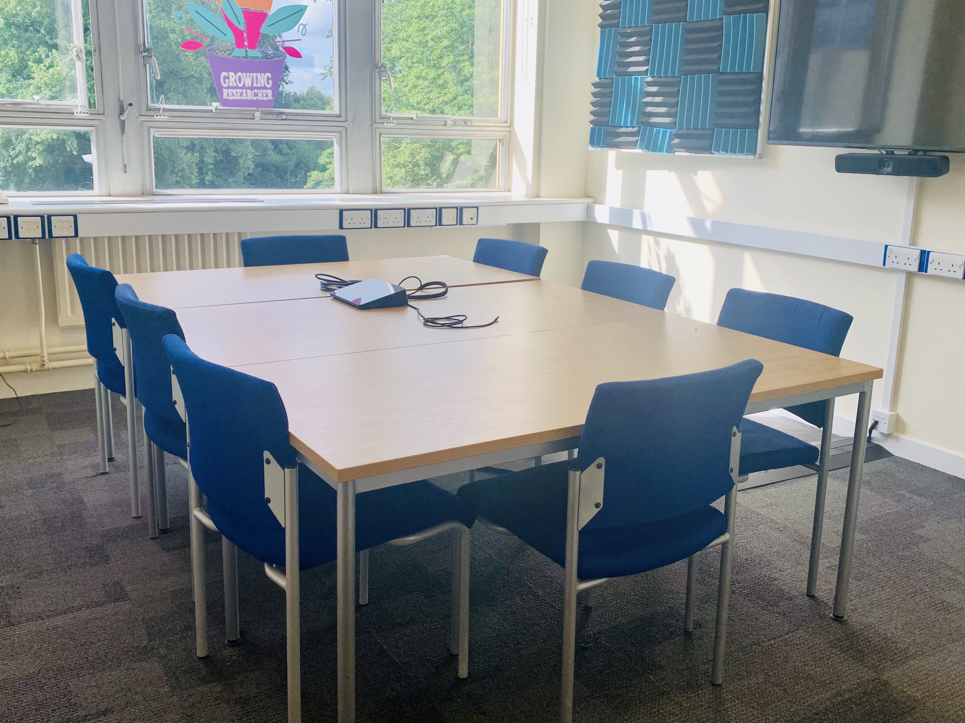

- There should be a group of three tables in the breakout space with 8 chairs around them.
- The breakout space can be booked directly by BDC staff and requested by PGRs and the university’s central PGR leadership team (e.g. APVC (PGR), PGR Applicant & Student Manager). To request the 2.21 breakout space as an external user, please email uob-pgr-hub@bristol.ac.uk. Booking requests from external users are likely to be declined unless connected to other PGR-related activity in the PGR Hub.
- To request the 2.21 breakout space as a PGR or as a member of the central PGR leadership team, please create a new Outlook event using your University of Bristol account and add SH PGR Hub 2.21 Breakout Space as the venue with the following table included in the Outlook event description. Use the Scheduling Assistant tab on the Outlook event to check the room’s availability before sending the request.
Lead organiser name & email
Activity title
Type of activity | [Meeting/Event/Study/Other]
Format of activity | [In person/Hybrid]
Number of attendees (in-person)
Relevance to PGR activities
Any additional information for BDC
- You will receive a notification once your booking has been approved or declined, usually within 2 working days of the request. Note that bookings are not confirmed until the approval notification has been received. BDC staff reserve the right to decline a booking if the event details change after the original request.

2.21 Audio-Visual Equipment and Hybrid Meetings
- The breakout space is equipped with a wall-mounted screen and integrated Logitech camera and microphone device for hybrid meetings. There is a touchscreen console for joining and controlling Microsoft Teams meetings as well as a USB-C cable for laptop connections. Instructions for use are available onsite.
- Please ensure that SH PGR Hub 2.21 Breakout Space is added to the Outlook event containing the relevant Microsoft Teams link for the best integrated Teams experience.

Please see the images of the configurations for 2.21 and 2.22.

